BDO India LLP
Software Requirements and Specification Document (SRS) of Training Management System (TMS) – PRAGATI SETU 1.0 Issuing Date: 20th October 2025
U.P. STATE RURAL LIVELIHOODS MISSION Lucknow, Uttar Pradesh







Document Details
Project Name | Training Management System (TMS) – PRAGATI SETU 1.0
Date: | 18-10-2025 | Release | Final Ver 1.0
Author | Ayush M Srivastava, Akash Tiwari
Owner | BDO India LLP
Client | U.P. State Rural Livelihood Mission (PRERNA)
Document Number | BDO-UPSRLM-SRS-v1-TMS’2025

Approvals
Name | Title | Date of Issue | Version
Sachin Mishra | Project Manager, BDO India LLP | 20-10-2025 | 1.0
Team BDO |  |  | 1.0

Distribution
Name | Title | Date of Issue | Version
Ms. Deepa Ranjan | Mission Director (MD) - UPSRLM | 20-10-2025 | 1.0
Ms. Niti Shrivastav | Joint Mission Director (JMD) - UPSRLM | 20-10-2025 | 1.0

Revision History
Version | Date | Author | Description | Approved By
1.0 | 18-10-2025 | Ayush M Srivastava (Software Developer), BDO India LLP | Finalized SRS | Sachin Mishra

Table of Contents
1. INTRODUCTION 8
1.1. Purpose 8
1.2. Scope 8
1.3. Definitions, Acronyms and Abbreviations 9
1.4. References 9
1.5. Document Conventions 9
1.6. Intended Audience 10
1.7. Technology Stack 10
1.8. References 10
2. OVERALL DESCRIPTION 11
2.1. Product Perspective 11
2.2. Product Functions 11
2.3. User Classes and Characteristics 11
2.4. Operating Environment 12
2.5. Design and Implementation Constraints 12
2.6. Assumptions and Dependencies 12
3. SYSTEM CONTEXT AND ARCHITECTURE 13
3.1. System Context 13
3.2. External Interfaces (Summary) 13
3.3. User Interface Overview (React.js) 13
4. SYSTEM FEATURES (HIGH-LEVEL) 14
4.1. Training Plan Management 14
4.2. Training Request Management 14
4.3. Batch Formation & Centre Proposal 14
4.4. Attendance Management 14
4.5. Payment Workflow 14
4.6. Training Closure 14
5. FRONTEND REQUIREMENTS (REACT.JS) 15
5.1. General UI Requirements 15
5.2. Accessibility Requirements 15
5.3. Navigation Requirements 15
6. DATABASE REQUIREMENTS (MYSQL) 16
6.1. General Requirements 16
6.2. MySQL Normalization Requirements 16
6.3. Data Retention 16
7. SYSTEM WORKFLOWS (HIGH-LEVEL) 17
7.1. Training Plan Workflow 17
7.2. Training Request Workflow 17
7.3. Batch Formation Workflow 17
7.4. Attendance Workflow 17
7.5. Payment Workflow 18
8. UML Diagrams 19
8.1. Use Case Diagram 19
8.2. Sequence Diagram 19
8.2.1. S1: SMMU Assigns Targets 19
8.2.2. S2: BMMU Creates Training Request 20
8.2.3. S3: Training Infra Setup 21
8.2.4. S4: DMMU Batch Approval 22
8.2.5. S5: Training Execution 22
8.2.6. S6: Batch Closure 23
8.2.7. S7: Training Request Closure 23
8.2.8. S8: DMMU Final Approval 24
8.2.9. S9: Certificate Generation 24
8.2.10. S10: Reporting & Closure 25
8.3. Activity Diagram 25
9. Data Flow Diagrams (All levels) 26
9.1. Level 0 26
9.2. Level 1 27
9.2.1. Process 1.0 Training Plan & Target Management 27
9.2.2. Process 2.0 Training Request Management 28
9.2.3. Process 3.0 Batch & Center Management 29
9.2.4. Process 4.0 Batch Approval Management 30
9.2.5. Process 5.0 Training Execution & Attendance 31
9.2.6. Process 6.0 Training Closure & Financial Review 32
9.2.7. Process 7.0 Certification & Reporting 33
10. System Context Diagram 34
11. FUNCTIONAL REQUIREMENTS (SUMMARY OF GROUPS) 35
11.1. Authentication Requirements 35
11.2. Role-Based Authorization 35
11.3. TRAINING PLAN MANAGEMENT (FR-TP) 36
11.3.1. Plan Creation 36
11.3.2. Plan Approval Workflow 36
11.3.3. Plan Targets 36
11.4. BENEFICIARY SELECTION MODULE (FR-BS) 36
11.4.1. Beneficiary Retrieval 36
11.4.2. Beneficiary Validation Rules 37
11.4.3. Beneficiary Assignment 37
11.5. TRAINING REQUEST MANAGEMENT (FR-TR) 37
11.5.1. Request Formation 37
11.5.2. Routing Logic 37
11.5.3. Request Status 37
11.6. BATCH FORMATION MODULE (FR-BF) 38
11.6.1. Batch Creation 38
11.6.2. Batch Verification 38
11.6.3. Batch Code Generation 38
11.7. TRAINER ASSIGNMENT MODULE (FR-TM) 38
11.7.1. Instructor Allocation 38
11.7.2. Trainer Availability 38
11.8. TRAINING CENTRE MANAGEMENT (FR-TCM) 39
11.8.1. Centre Registration 39
11.8.2. Centre Verification 39
11.9. DAY-1 EKYC MODULE (FR-EKYC) 39
11.9.1. Participant Identity Verification 39
11.9.2. Verification Rules 39
11.10. ATTENDANCE MANAGEMENT (FR-ATT) 39
11.10.1. Daily Attendance Upload 39
11.10.2. Attendance Computation Rules 39
11.10.3. Error Handling 40
11.11. PAYMENT SUBMISSION MODULE (FR-PAY) 40
11.11.1. Trainer Payment Submission 40
11.11.2. Training Partner Payment Submission 40
11.11.3. Payment Verification 40
11.11.4. Payment Approval 40
11.12. TRAINING CLOSURE MODULE (FR-CL) 41
11.12.1. Closure Requirements 41
11.12.2. Closure Approval 41
11.13. REPORTING MODULE (FR-REP) 41
11.13.1. Standard Reports 41
11.13.2. Export Requirements 41
12. NON-FUNCTIONAL REQUIREMENTS (OVERVIEW) 42
12.1. Performance Requirements (NFR-PERF) 42
12.2. Security Requirements (NFR-SEC) 42
12.2.1. Authentication 42
12.2.2. Authorization 42
12.2.3. Data & API Security 42
12.2.4. Logging & Auditing 43
12.2.5. Reliability (NFR-REL) 43
12.2.6. Maintainability (NFR-MAINT) 43
12.2.7. Portability (NFR-PORT) 43
12.2.8. Usability (NFR-USE) 43
13. DATA DICTIONARY 44
13.1. master_roles 44
13.2. master_user 44
13.3. master_state 45
13.4. master_district 46
13.5. master_block 47
13.6. master_geouserscope 47
13.7. SoftDeleteMixin 48
13.8. tms_trainingtheme 48
13.9. tms_trainingplan 49
13.10. tms_mastertrainer 49
13.11. tms_mastertrainercertificate 50
13.12. tms_trainingpartner 50
13.13. tms_tpbanks (Training Partner Bank) 51
13.14. tms_tpcontactperson (Training Partner Contact Person) 52
13.15. tms_trainingpartnercentre 52
13.16. tms_trainingpartnercentrerooms 53
13.17. tms_tpcp_centre (TPCP → Centre Mapping) 53
13.18. tms_trainingpartnersubmission 54
13.19. tms_trainingpartnertargets 54
13.20. tms_trpuserscope 55
13.21. tms_trainingrequest 55
13.22. tms_batch 56
13.23. tms_trbeneficiary 56
13.24. tms_trtrainer 57
13.25. tms_batchschedule 57
13.26. tms_batchmastertrainer 58
13.27. tms_batchbeneficiary 58
13.28. tms_batchtrainer 59
13.29. tms_batchekycverification 59
13.30. tms_batchattendance 60
13.31. tms_participantattendance 60
13.32. tms_tpbatchcostbreakup 61
13.33. tms_batchcost 61
13.34. tms_batchmedia 62
13.35. tms_batchclosurerequest 62
13.36. tms_batchparticipantcertificate 63
13.37. tms_trclosure 63
13.38. tms_batchreport 64
13.39. master_panchayat 64
13.40. master_village 65
14. CONSTRAINTS, STANDARDS, AND GUIDELINES (OVERVIEW) 66
14.1. LokOS Integration 66
14.2. LokOS Beneficiary Retrieval Cycle 66
14.3. Attendance CSV Integration 66
15. ERROR HANDLING REQUIREMENTS 67
16. AUDIT & LOGGING REQUIREMENTS 68
17. DEPLOYMENT REQUIREMENTS 69
17.1. Backend 69
17.2. Frontend 69
18. VALIDATION AND ACCEPTANCE CRITERIA 70
19. REQUIREMENTS TRACEABILITY MATRIX (RTM) 71
20. CLOSING NOTES 75

- INTRODUCTION
  - Purpose
The purpose of this Software Requirements Specification (SRS) is to define, in a formal and testable manner, all functional and non-functional requirements of the Training Management System (TMS). The SRS serves as the baseline for design, implementation, testing, acceptance, and maintenance of the TMS. The document is drafted in accordance with ISO/IEC/IEEE 29148 and government e-governance standards. This document establishes the authoritative baseline of requirements for:
- Development
- Testing
- Quality assurance
- Procurement
- Audit
- Acceptance
- Maintenance
- Future scalability
  - Scope
The TMS is a role-based Management Information System (MIS) designed to support end-to-end lifecycle management of trainings under UPSRLM. It covers:
- Creation and approval of training plans.
- Formation of training requests and batches.
- Selection and management of beneficiaries and trainers.
- Registration and verification of training centers.
- Day 1 biometric eKYC and daily attendance capture via fingerprint CSV.
- Submission, review, and approval of training-related payments.
- Training closure and generation of reports and certificates.
The system supports BMMU, DMMU, SMMU, Training Partners, and Master Trainers, integrating data from LokOS, SHG/Beneficiary databases, and state-level training frameworks. This SRS supersedes all previous informal descriptions and shall be the single source of truth.

  - Definitions, Acronyms and Abbreviations
S.No. | Acronym | Definition
1 | BMMU | Block Mission Manager User
2 | DMMU | District Mission Manager User
3 | SMMU | State Mission Manager User
4 | TP | Training Partner
5 | MT | Master Trainer
6 | SHG | Self Help Group
7 | eKYC | Electronic Know Your Customer
8 | MIS | Management Information System
9 | API | Application Programming Interface
10 | RTM | Requirements Traceability Matrix
  - References
- UPSRLM Training Framework and Guidelines.
- Guidelines for Indian Government Websites (GIGW) 3.0
- APISETU documentation for LokOS master and production data.
  - Document Conventions
- SHALL = Mandatory system behavior
- SHOULD = Recommended but not mandatory
- MAY = Optional behavior
- USER refers to authenticated system roles
- ALL DATA MODELS refer to MySQL schema

  - Intended Audience
- UPSRLM IT Division
- Third-party auditors
- Development teams
- QA and testing teams
- System administrators
- Government procurement officials
  - Technology Stack
The TMS is an independent MIS built on:
- Backend: Django REST APIs
- Frontend: React.js
- Database: MySQL 8
- Deployment: Ubuntu 22.04 LTS
The system replaces manual Excel-based processes with a unified automated workflow.
  - References
S.No. | Documents | Issue Date
1 | As-Is Process Study (Ver. 1) - BDO-UPSRLM-AIPS-v1-TMS’2025 | 12-09-2025
2 | As-Is Process Study (Ver. 2) - BDO-UPSRLM-AIPS-v2-TMS’2025 | 17-09-2025
3 | Functional Requirements and Specification Document (FRS) - BDO-UPSRLM-FRS-v1-TMS’2025 | 02-10-2025
4 | Guidelines for Indian Government Websites (GIGW) Document | -

- OVERALL DESCRIPTION
  - Product Perspective
The Training Management System is a web-based solution which shall be developed using cutting-edge technologies. It will transform manually managed training system by streamlining all processes and provide a unified platform to plan a training and accomplish it.
  - Product Functions
At a high level, the system provides the following functions:
- Training Plan Management – creation, review, and approval of training plans.
- Beneficiary Management – viewing, filtering, and assigning beneficiaries to training requests and batches.
- Batch Formation – defining batches, centers, schedules, and trainers.
- Training Centre Management – registration and verification of training centers and rooms.
- Attendance Management – biometric eKYC on Day 1 and daily attendance via CSV files.
- Payment Management – capturing and approving payment requests from trainers and training partners.
- Reporting – dashboards and analytical reports at block, district, and state level.
  - User Classes and Characteristics
User Type | System Role | Access Characteristics
BMMU | Block-level authority | Creates training plans, nominates batches, adds beneficiaries, initial verification
DMMU | District authority | Approves/rejects batches, validates centers, approves payments
SMMU | State authority | Theme-specific approvals, target allocation, state-level monitoring
Training Partner | Operational workforce | Creates training requests, forms batches, uploads attendance, submits invoices
Master Trainer | Resource personnel | Conducts sessions, uploads documents, tracks assigned batches
Admin | Technical management | Full system management & maintenance

  - Operating Environment
- Server OS: Ubuntu Linux 22.04 LTS or equivalent.
- Backend: Python 3.x, Django 4.x, Django REST Framework.
- Database: MySQL 8.x with InnoDB storage engine.
- Frontend: React.js SPA, using Axios or equivalent for API calls.
- Browsers: Latest versions of Google Chrome, Mozilla Firefox, and Microsoft Edge.
- Network: Accessible over secure HTTPS connections using TLS 1.2 or higher.
  - Design and Implementation Constraints
- The system shall use MySQL as the primary relational database.
- The frontend shall be implemented in React.js and shall not rely on Django HTML templates for rendering.
- The system shall comply with government IT security policies for access control, encryption, and logging.
- All code shall follow PEP8 and internal coding guidelines.
- Integration with LokOS and attendance devices shall follow published protocols.
  - Assumptions and Dependencies
- LokOS APIs remain available and stable for master data sync.
- Biometric attendance devices are capable of exporting attendance in agreed CSV format.
- Network connectivity is sufficiently reliable for synchronous operations during working hours.
- UPSRLM provides master data for training plans, trainers, and partners on a periodic basis.
- SYSTEM CONTEXT AND ARCHITECTURE
  - System Context
The TMS sits between administrative users, training partners, trainers, and external systems. All human users interact through the React.js frontend, which communicates exclusively with the Django REST API. The backend interacts with MySQL for persistent storage and with external systems such as LokOS and biometric attendance devices (indirectly via CSV files).
  - External Interfaces (Summary)
- LokOS Integration Interface – retrieval of state, district, block, panchayat, and village master data.
- Attendance CSV Interface – ingestion of daily punch files from biometric devices.
- File Storage Interface – storage of media and document uploads on the server.
  - User Interface Overview (React.js)
The React.js frontend shall provide role-based dashboards and forms, including but not limited to:
- BMMU Dashboard – beneficiary overview, training plans, pending requests.
- DMMU Dashboard – district beneficiary analytics, pending training requests, closure actions.
- SMMU Dashboard – state-level overviews, thematic plan approvals, target allocation.
- Training Partner Dashboard – training requests, batch management, training batches costs.
- Training Partner Contact Person Dashboard - attendance uploads, batch related media uploads, batch cost breakups.
- Master Trainer Dashboard – assigned batches, personal education, achievements, certificates.
- SYSTEM FEATURES (HIGH-LEVEL)
  - Training Plan Management
- Bottom-up plan creation
- Multi-level approval
- State-assigned targets
  - Training Request Management
- Module selection
- Beneficiary/Trainer selection
- Automatic assignment of training partners
  - Batch Formation & Centre Proposal
- Centre registration by Training Partners
- Multi-stage verification
- Automatic trainer allocation
  - Attendance Management
- Day-1 biometric eKYC
- Daily CSV attendance punch file ingestion
- Participant presence computation
- Trainer attendance calculation
  - Payment Workflow
- Trainer’s payment submission
- Training Partner’s cost submission
- DMMU/SMMU approval workflows
  - Training Closure
- Uploading TA/DA
- Certificate dispatch
- Consolidated training report generation

- FRONTEND REQUIREMENTS (REACT.JS)
The system shall adhere to the following:
  - General UI Requirements
- The UI SHALL be implemented in React.js using functional components.
- The UI SHALL not use server-side rendering.
- The UI SHALL communicate exclusively via REST APIs.
- The UI SHALL support pagination up to 50,000 records.
- The UI SHALL restrict views based on user roles.
  - Accessibility Requirements
- The UI SHALL comply with WCAG 2.1 Level AA.
- All form inputs SHALL include labels and error messages.
  - Navigation Requirements
- The system SHALL display a role-based navigation sidebar.
- The system SHALL provide breadcrumb navigation on all detail pages.
- DATABASE REQUIREMENTS (MYSQL)
  - General Requirements
- All data SHALL be stored in MySQL 8 InnoDB engine.
- All tables SHALL support foreign key relationships.
- All timestamps SHALL be time zone-aware (Asia/Kolkata).
- All audit fields SHALL be maintained: created at, updated at, created by.
  - MySQL Normalization Requirements
- The database SHALL be designed to at least 3rd Normal Form.
- Junction tables SHALL be used for Many-to-Many relationships, such as:
  - TrainerBatchRegistration
  - BeneficiaryBatchRegistration
  - TPBatchParticipation
  - Data Retention
- Attendance records SHALL be retained for 5 years.
- Certificates SHALL be retained indefinitely unless policy changes.
- Beneficiary master data SHALL never be deleted, only soft-deactivated.
- SYSTEM WORKFLOWS (HIGH-LEVEL)
  - Training Plan Workflow
- BMMU creates plan
- Thematic expert verifies
- SMMU approves state-level plans
- Automatic training partner assignment
  - Training Request Workflow
- BMMU selects module
- BMMU selects beneficiaries
- BMMU submits training request
- Request forwarded to Training Partner with Assigned Module Target
- Training Partner will create batches out of Training Request from different Blocks
  - Batch Formation Workflow
- TP selects beneficiaries
- Registers Training Centre
- Select Registered Centre
- Propose to DMMU
- DMMU assigns trainers
- DMMU verifies & approves proposal
  - Attendance Workflow
- Day 1 biometric eKYC
- Daily CSV punch file uploads until completion
- Validation rules applied
- Automated computation of present/absent status

  - Payment Workflow
- Trainer uploads payment details
- Partner uploads cost sheet
- DMMU reviews
- SMMU final approval (for state-level programs)

- UML Diagrams
  - Use Case Diagram
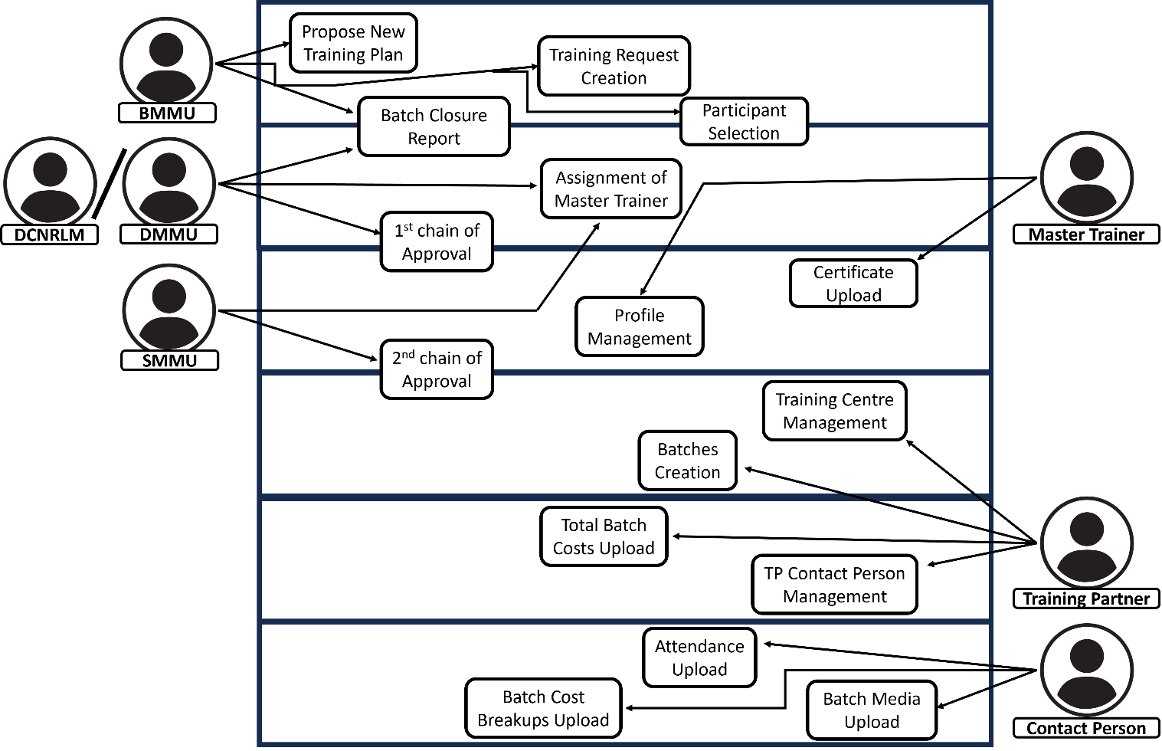
  - Sequence Diagram
    - S1: SMMU Assigns Targets
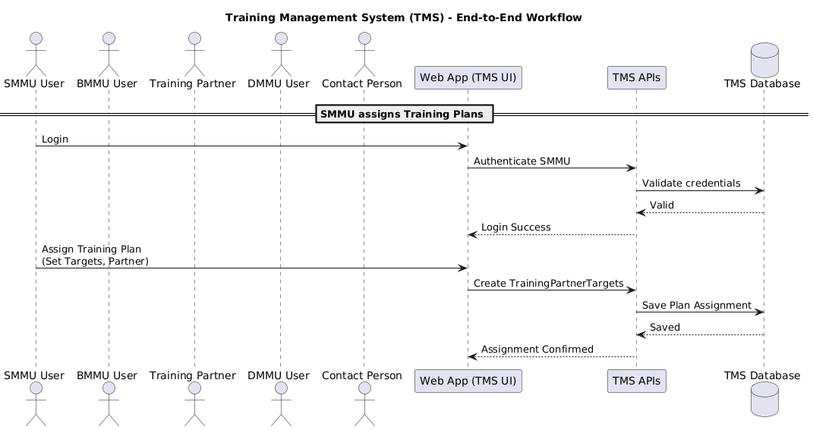
    - S2: BMMU Creates Training Request
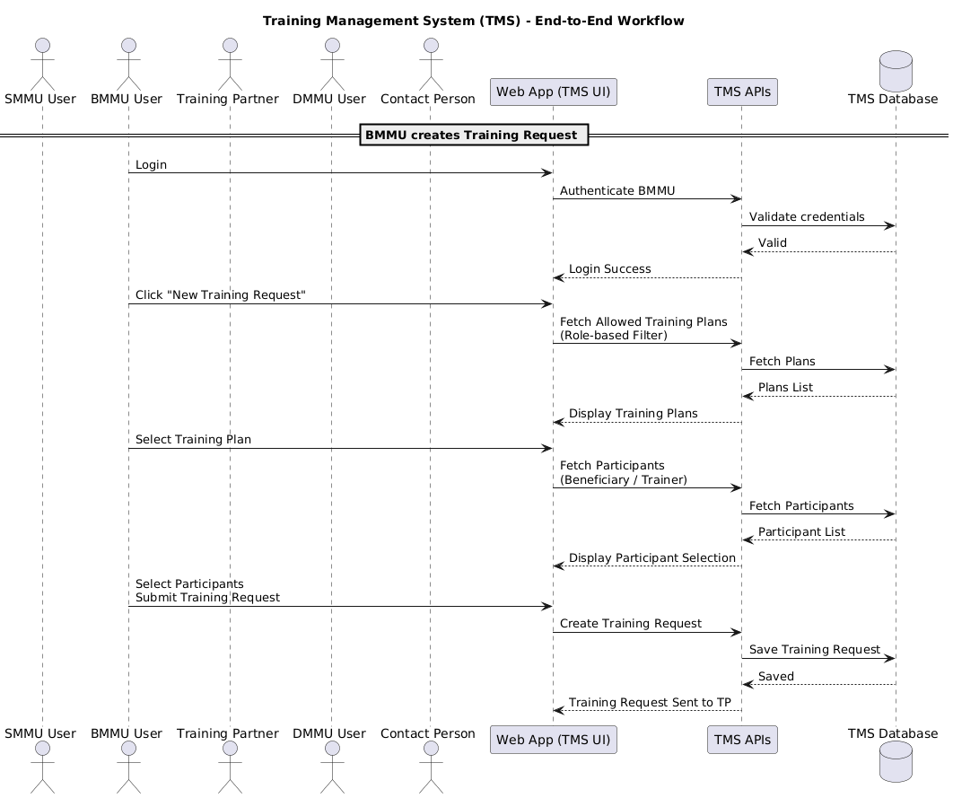
    - S3: Training Infra Setup
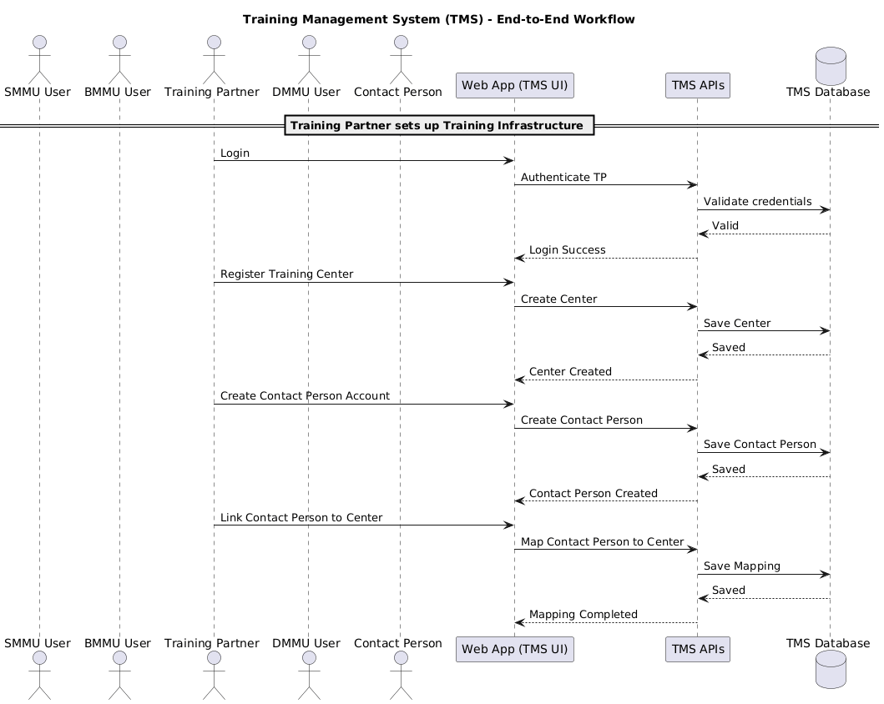
    - S4: DMMU Batch Approval
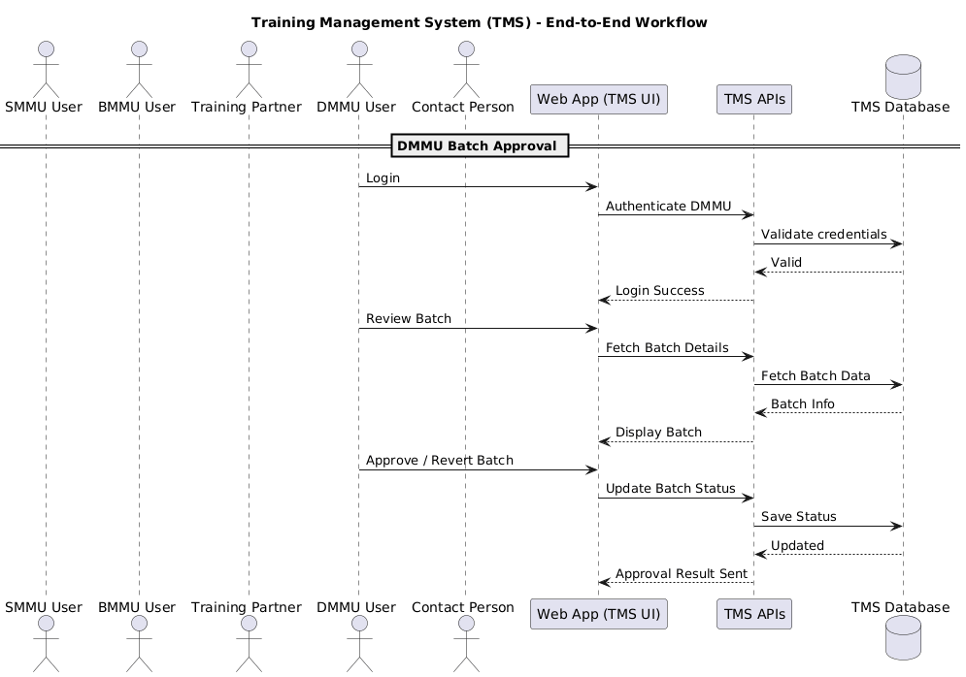
    - S5: Training Execution
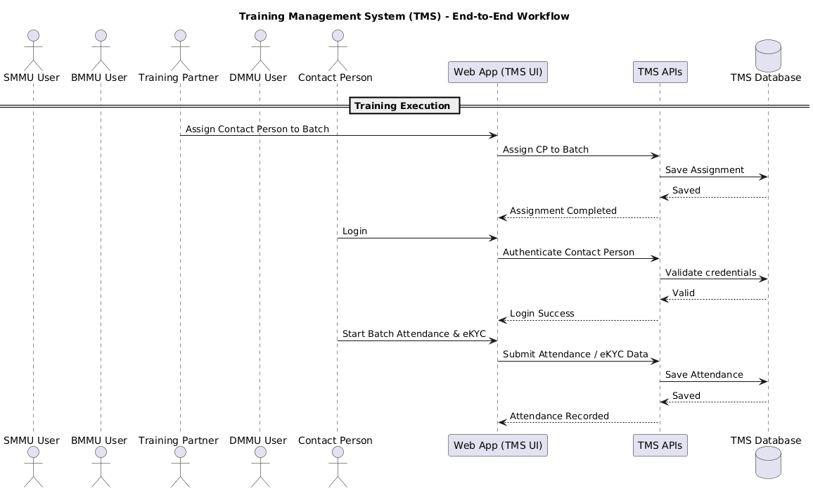
    - S6: Batch Closure
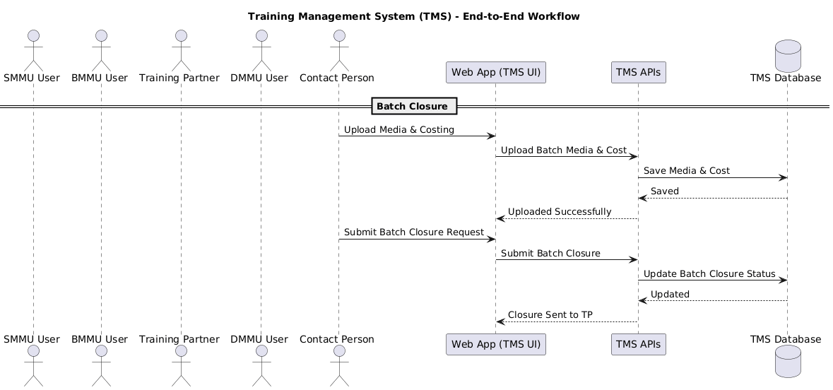
    - S7: Training Request Closure
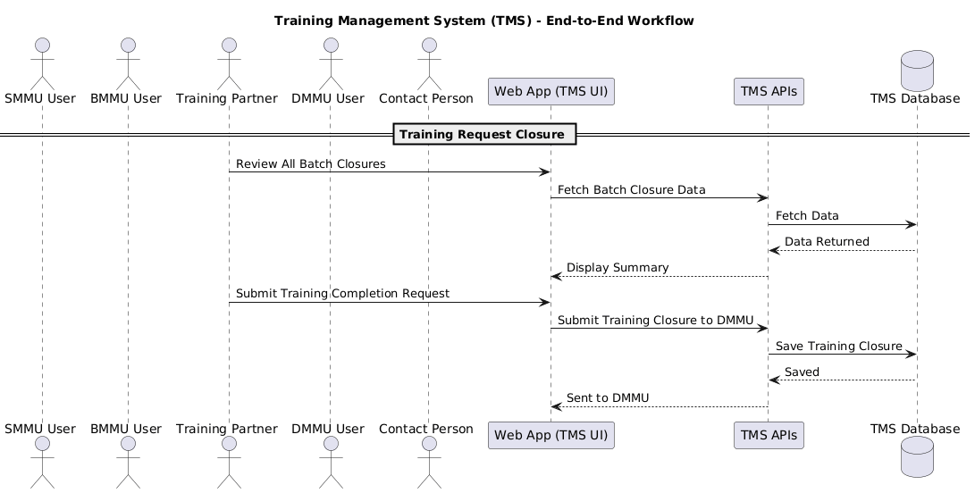
    - S8: DMMU Final Approval
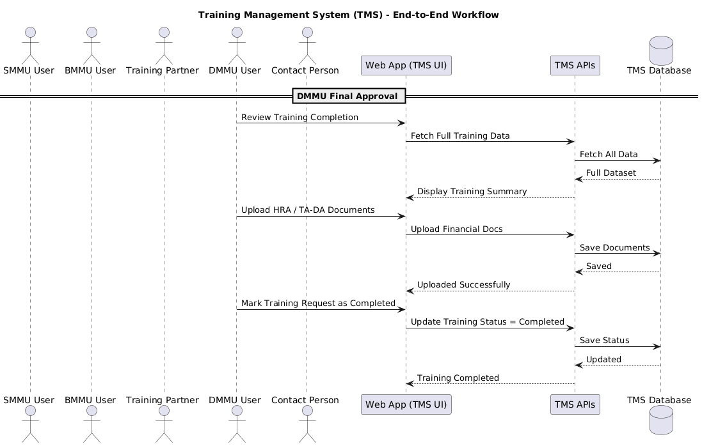
    - S9: Certificate Generation
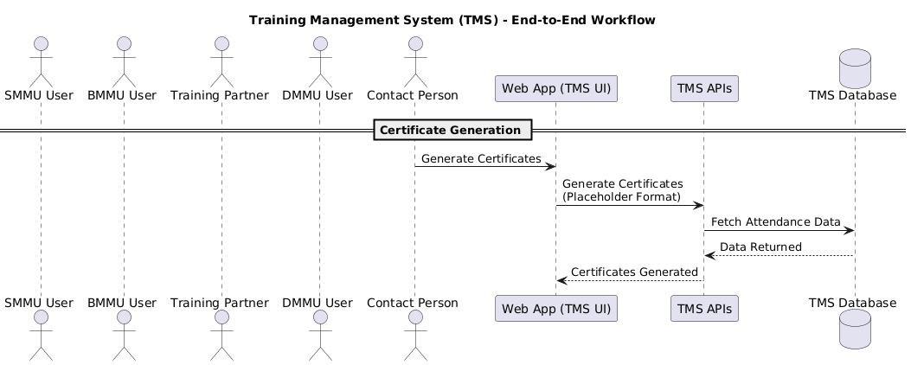
    - S10: Reporting & Closure
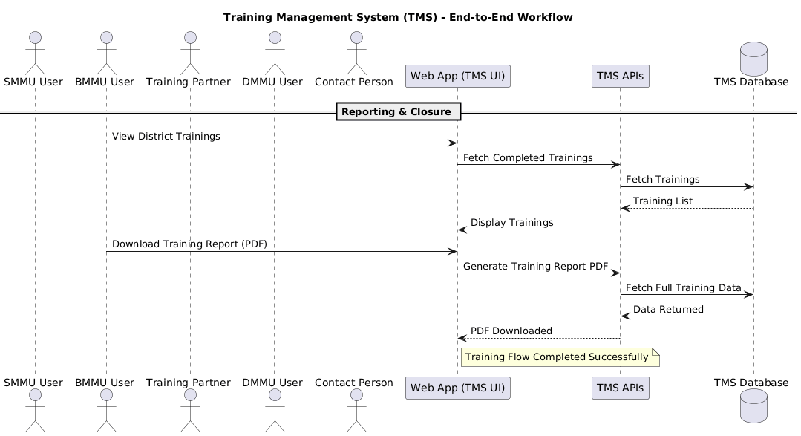
  - Activity Diagram

- Data Flow Diagrams (All levels)
  - Level 0
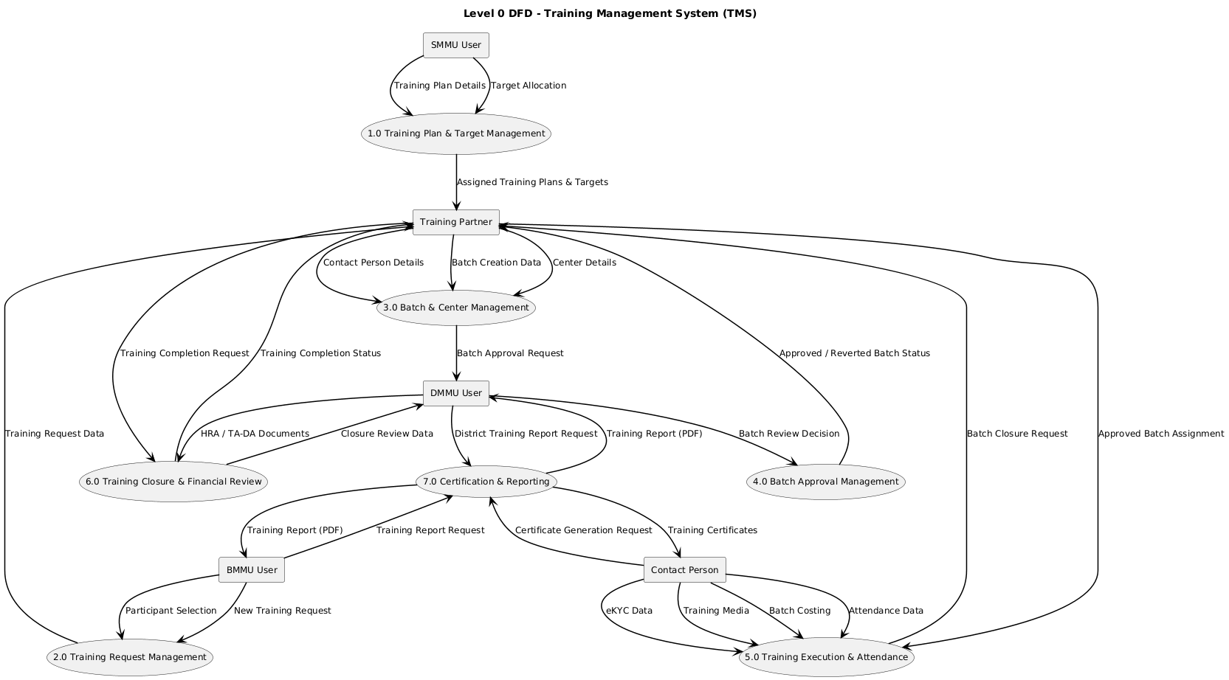
  - Level 1
    - Process 1.0 Training Plan & Target Management
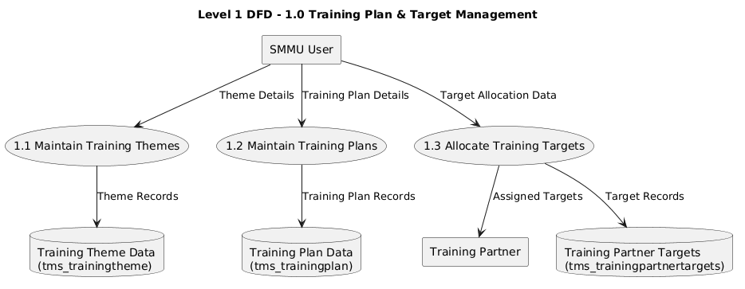
    - Process 2.0 Training Request Management
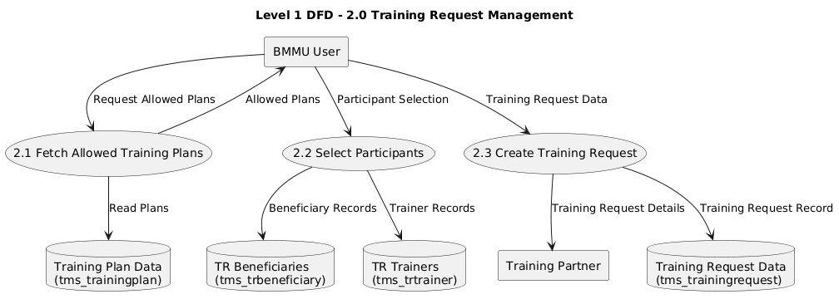
    - Process 3.0 Batch & Center Management
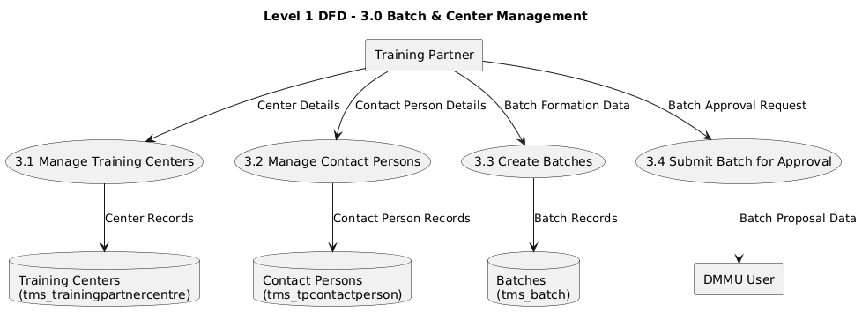
    - Process 4.0 Batch Approval Management
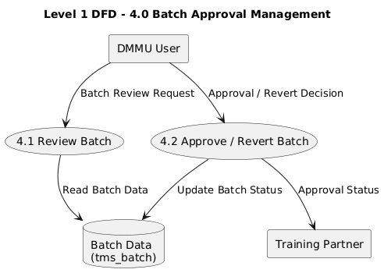

    - Process 5.0 Training Execution & Attendance
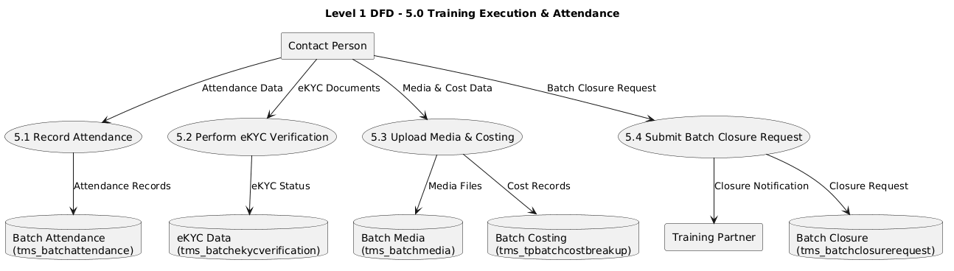

    - Process 6.0 Training Closure & Financial Review
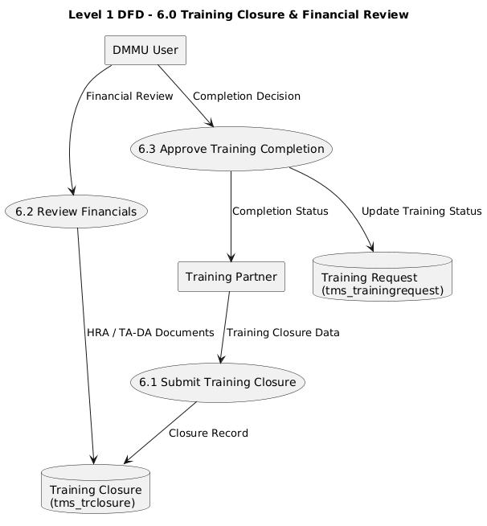
    - Process 7.0 Certification & Reporting

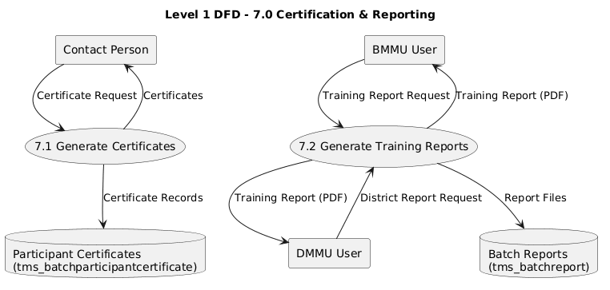
- System Context Diagram
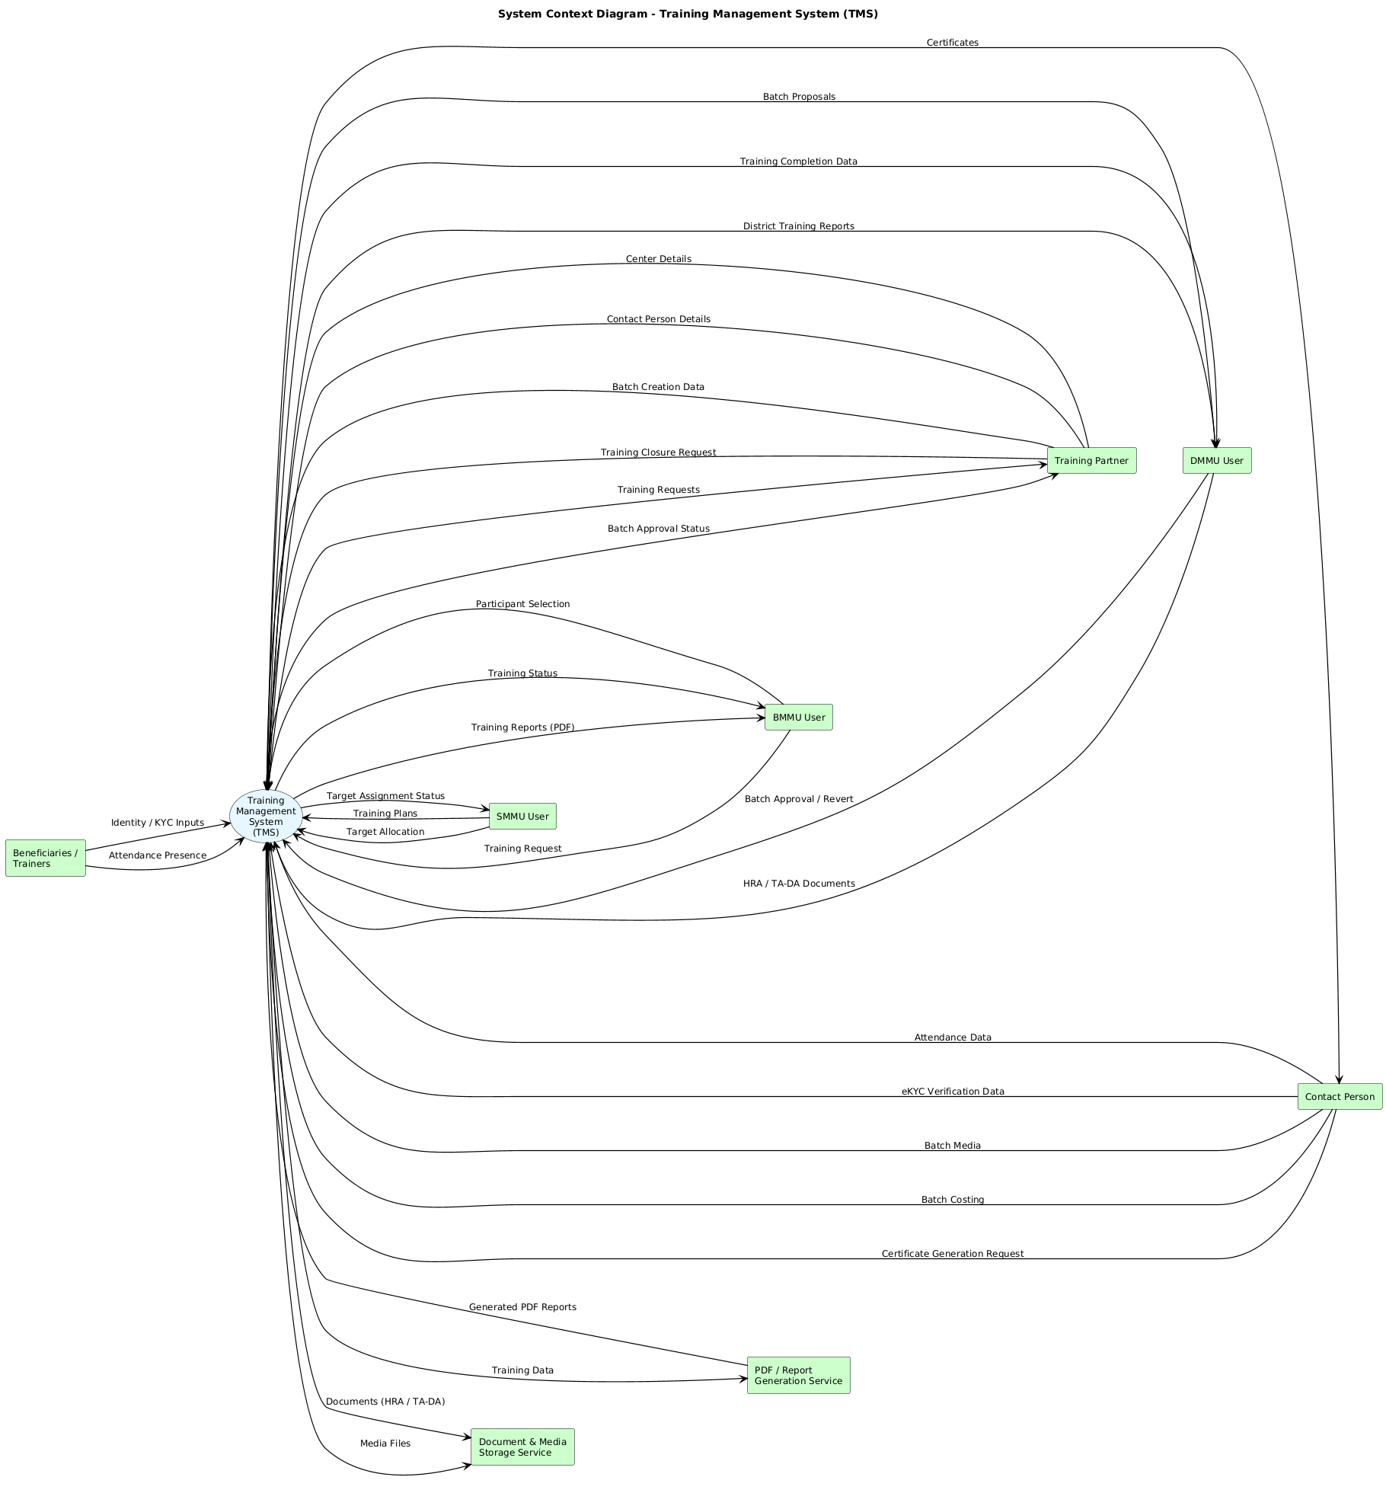
- FUNCTIONAL REQUIREMENTS (SUMMARY OF GROUPS)
This section provides a grouped summary of key functional requirement categories. Detailed requirement statements are available in the master requirement catalogue and are linked in the RTM.
Groups include:
- FR-UA – Authentication and Authorization.
- FR-TP – Training Plan Management.
- FR-BS – Beneficiary Selection.
- FR-TR – Training Request Management.
- FR-BF – Batch Formation.
- FR-TCM – Training Centre Management.
- FR-TM – Trainer Assignment.
- FR-EKYC – Day-1 eKYC.
- FR-ATT – Attendance Management.
- FR-PAY – Payment Management.
- FR-CL – Training Closure.
- FR-REP – Reporting and Analytics.
  - Authentication Requirements
- The system shall authenticate users using a username–password mechanism.
- The system shall enforce strong password hashing using PBKDF2 or bcrypt.
- The system shall invalidate sessions upon logout.
- The system shall automatically terminate the user’s logged-in session after 12 hours of inactivity.
- The system shall prevent simultaneous multi-device login for Master Trainers and Training Partners.
  - Role-Based Authorization
- The system shall restrict access to dashboards based on the user’s role.
- The system shall enforce the following jurisdiction rules:
  - BMMU → Block-level beneficiaries only
  - DMMU → District-level beneficiaries only
  - SMMU → State-level aggregated view
- The system shall restrict API access using role-based middleware.
  - TRAINING PLAN MANAGEMENT (FR-TP)
    - Plan Creation
- The system shall allow BMMU, DMMU, and SMMU to create new training plans.
- The system shall require entry of:
  - Theme
  - Module
  - Training level
  - Duration/days
  - Objectives
- The system shall retrieve training themes from the master TrainingPlan database.
    - Plan Approval Workflow
- The system shall route BMMU-created plans to the designated SMMU thematic expert.
- The system shall route DMMU-created plans to the designated SMMU thematic expert.
- The system shall allow thematic experts to approve or reject plans.
- The system shall record reasons for rejection.
- The system shall prevent use of a plan until approved.
    - Plan Targets
- The system shall allow SMMU users to assign annual training targets to Training Partners.
- The system shall enforce that performance metrics are linked to past batch history.
  - BENEFICIARY SELECTION MODULE (FR-BS)
    - Beneficiary Retrieval
- The system shall fetch beneficiary master data from the MySQL “Beneficiary” table.
- The system shall allow filtering by:
  - SHG code
  - Member code
  - Village
  - Panchayat
  - Block
- The system shall restrict results to the logged-in user’s jurisdiction.
    - Beneficiary Validation Rules
- The system shall prevent selecting beneficiaries outside the training level:
  - Block-level → Only block beneficiaries
  - District-level → Any beneficiaries of that district
- The system shall validate that beneficiaries are not “inactive.”
    - Beneficiary Assignment
- The system shall allow multi-selection of beneficiaries.
- The system shall ensure a beneficiary cannot be assigned to overlapping batches.
  - TRAINING REQUEST MANAGEMENT (FR-TR)
    - Request Formation
- The system shall allow Training Partners to form a Training Request using:
  - Selected plan
  - Selected beneficiaries
  - Proposed centre
- The system shall generate a unique Training Request ID.
    - Routing Logic
- The system shall automatically route:
  - Block-level requests → DMMU
  - District-level requests → DMMU
  - State-level requests → SMMU
    - Request Status
The system shall maintain statuses:
- BATCHING
- PENDING APPROVAL
- APPROVED
- REVERTED
- REJECTED
  - BATCH FORMATION MODULE (FR-BF)
    - Batch Creation
- The system shall allow Training Partners to divide beneficiaries into batches.
- The system shall require:
  - Start date
  - End date
  - Training centre
  - Beneficiary List
    - Batch Verification
- The system shall require DMMU to verify:
  - Centre location
  - Photos
  - Beneficiary list
- The system shall allow DMMU to approve or reject a batch.
    - Batch Code Generation
- The system shall generate a unique Batch Code following the format:
BLK-DIS-MMYY-NNN
  - TRAINER ASSIGNMENT MODULE (FR-TM)
    - Instructor Allocation
- The system shall allow DMMU to assign trainers according to training level:
  - Block → BRP
  - District → DRP
  - State → SRP
- The system shall prevent assigning a trainer who is currently allocated to an active batch.
    - Trainer Availability
- The system shall compute availability using records in the TrainerBatchParticipation table.
- The system shall mark a trainer “Unavailable” during an active batch.
  - TRAINING CENTRE MANAGEMENT (FR-TCM)
    - Centre Registration
- The system shall allow Training Partners to register centre details including:
  - Address
  - GPS coordinates
  - Photos (min. 4 mandatory categories)
    - Centre Verification
- The system shall allow DMMU to verify centre submissions.
- The system shall automatically link centre verification with batch approvals.
  - DAY-1 EKYC MODULE (FR-EKYC)
Based on the workflow described in the Dev Guide:
“Day 1: eKYC verification of participants and master trainers is carried out.”
    - Participant Identity Verification
- The system shall require each participant to undergo biometric eKYC on Day-1.
- The system shall store eKYC verification information in BatchEkycVerification table.
    - Verification Rules
- The system shall flag attendance as invalid if eKYC is missing.
- The system shall prevent daily attendance marking without first completing eKYC.
  - ATTENDANCE MANAGEMENT (FR-ATT)
    - Daily Attendance Upload
- The system shall accept exactly one CSV attendance file per day per batch.
- The system shall parse CSV containing punch logs for IN and OUT.
- The system shall support attendance for:
  - Participants
  - Master Trainers
    - Attendance Computation Rules
- The system shall compute the presence of an individual if at least:
  - One valid IN punch AND One valid OUT punch exists.
- The system shall support multiple IN/OUT pairs in a single day.
    - Error Handling
- The system shall reject CSV files containing:
  - Invalid participant IDs
  - Duplicate entries
  - Altered timestamps
- The system shall generate detailed error logs.
  - PAYMENT SUBMISSION MODULE (FR-PAY)
    - Trainer Payment Submission
- The system shall allow trainers to upload payment requests including:
  - Fee components
  - Bank details
  - Attendance-based fee computation
    - Training Partner Payment Submission
- The system shall allow Training Partners to upload:
  - Venue cost
  - Infrastructure cost
  - Training material cost
  - Miscellaneous cost
    - Payment Verification
- The system shall allow DMMU to validate:
  - Uploaded invoices
  - Attendance-based calculations
  - Supporting documents

    - Payment Approval
- The system shall route approvals based on training level.
- The system shall maintain digital records of approvals.
  - TRAINING CLOSURE MODULE (FR-CL)
    - Closure Requirements
- The system shall permit closure only after final attendance verification.
- The system shall require uploading:
  - TA/DA documents
  - Training certificates
    - Closure Approval
- The system shall allow DMMU/SMMU to approve closure.
- The system shall generate the Final Training Report.
  - REPORTING MODULE (FR-REP)
    - Standard Reports
The system shall generate the following reports:
- Village-wise Training Count
- Block-wise Training Count
- District-wise Training Count
- Theme-wise Training Report
- Module-wise Training Report
- Trainer Performance Report
- Beneficiary Training History Report
    - Export Requirements
- The system shall export reports to Excel and PDF.
- The system shall support role-filtered reporting.
- NON-FUNCTIONAL REQUIREMENTS (OVERVIEW)
Non-functional requirements apply system-wide and cover performance, security, reliability, maintainability, portability, usability, and compliance. These are elaborated in the full SRS and reflected in the RTM as NFRs.
  - Performance Requirements (NFR-PERF)
- The system shall support a minimum concurrency of 2,000 simultaneous users.
- The system shall respond to all dashboard API requests within:
  - < 2 seconds for 95th percentile
  - < 5 seconds worst case
- The system shall generate reports (village/block/district) within 8 seconds for up to 100,000 records.
- The system shall process CSV attendance files (1,000 rows) in under 3 seconds.
- The system shall run daily batch processing (trainer payouts, completion checks) within 15 minutes.
- The system shall allow React tables to load paginated results within 1.5 seconds.
  - Security Requirements (NFR-SEC)
    - Authentication
- The system shall enforce strong password policies:
  - Min 8 characters
  - 1 uppercase, 1 number, 1 special character
- The system shall block accounts after five failed logins.
- The system shall use HTTPS with TLS 1.2+.
    - Authorization
- The system shall follow Role-Based Access Control (RBAC).
- The system shall restrict all endpoints by role middleware.
- The system shall prevent access across jurisdictions (BMMU cannot access another block).
    - Data & API Security
- The system shall encrypt all sensitive data at rest.
- The system shall return only sanitized error messages.
- The system shall validate file uploads (CSV mime type, size < 5MB).
- The system shall prohibit direct DB exposure; all access must be API-based.
- The system shall prevent direct API access.
- The system shall incorporate Secure and Hashed API ID and KEY for future integration and access of APIs.
    - Logging & Auditing
- The system shall record all authentication events.
- The system shall log all CRUD activity, including request payloads.
- The system shall maintain immutable audit logs for 7 years.
    - Reliability (NFR-REL)
- The system shall maintain 99% uptime, excluding scheduled maintenance.
- The system shall support auto-rollback on failed DB transactions.
- The system shall ensure no attendance data loss occurs during CSV upload.
    - Maintainability (NFR-MAINT)
- The system shall be built on modular Django apps:
  - core
  - TMS
- The system shall store configuration in environment variables.
- The system shall allow database migration via Django migrations with MySQL engine.
- The system shall enforce PEP8 coding standards.
    - Portability (NFR-PORT)
- The system shall be deployable on any Linux distribution (Ubuntu recommended).
- The system shall support migration between MySQL → PostgreSQL in future.
- The frontend shall run on all modern browsers (Chrome, Edge, Firefox).
    - Usability (NFR-USE)
- The system shall follow Government UI/UX guidelines.
- The system shall include breadcrumb navigation on all detail views.
- The system shall show clear error messages.
- The system shall support keyboard navigation and screen reader access.
- DATA DICTIONARY
The TMS data model is implemented in MySQL and includes core user tables, geographic master data, resource tables (beneficiaries, SHGs, trainers, partners), batch formation tables, center tables, and reporting tables.
  - master_roles
Field name | Type | Key / Creation | Notes / Constraints
id | BigAutoField | PK | Auto-increment primary key
name | CharField(100) | Unique | Role name
role_type | CharField(3) | — | Short role code
created_at | DateTimeField | — | Creation timestamp
updated_at | DateTimeField | — | Last update timestamp

  - master_user
Field name | Type | Key / Creation | Notes / Constraints
id | BigAutoField | PK | User identifier
username | CharField(150) | Unique | Login username
password | CharField(255) | — | Hashed password
recovery_email | CharField(255) | — | Nullable
recovery_mobile | CharField(20) | — | Nullable
pass_attempt_no | IntegerField | — | Failed login attempts
role | FK → master_roles.id | FK | DO_NOTHING
is_active | IntegerField | — | 1 = active
last_active_on | DateTimeField | — | Nullable
is_suspended | IntegerField | — | Status flag
suspended_on | DateTimeField | — | Nullable
is_locked | IntegerField | — | Lock flag
locked_on | DateTimeField | — | Nullable
pass_updated_at | DateTimeField | — | Nullable
pass_updated_by | FK → master_user.id | Self-FK | Nullable
TH_urid | CharField(36) | Unique | External UUID
created_at | DateTimeField | — | Nullable
updated_at | DateTimeField | — | Nullable
deleted_at | DateTimeField | — | Soft delete
created_by | FK → master_user.id | Self-FK | Nullable
updated_by | FK → master_user.id | Self-FK | Nullable
deleted_by | FK → master_user.id | Self-FK | Nullable

  - master_state
Field name | Type | Key / Creation | Notes
state_id | IntegerField | PK | State identifier
state_name_en | CharField(255) | — | English name
state_name_hi | CharField(255) | — | Hindi name
state_name_local | CharField(255) | — | Local language
state_short_name_en | CharField(10) | — | Abbreviation
category | PositiveIntegerField | — | State category
lgd_code | IntegerField | — | LGD mapping
state_code | IntegerField | — | Govt code
kyc_flag | IntegerField | — | KYC indicator
is_active | IntegerField | — | Status
created_at | DateTimeField | — | Timestamp
updated_at | DateTimeField | — | Timestamp

  - master_district
Field name | Type | Key / Creation | Notes
district_id | BigIntegerField | PK | District identifier
district_code | CharField(50) | — | Govt code
state | FK → master_state.state_id | FK | Mandatory
mandal | FK → master_mandal.id | FK | Nullable
district_name_en | CharField(255) | — | English name
district_short_name_en | CharField(50) | — | Abbrev
district_name_local | CharField(255) | — | Local
lgd_code | CharField(50) | — | LGD
language_id | CharField(20) | — | Language
created_at | DateTimeField | — | Timestamp
updated_at | DateTimeField | — | Timestamp

  - master_block
Field name | Type | Key / Creation | Notes
block_id | BigIntegerField | PK | Block identifier
state | FK → master_state | FK | Mandatory
district | FK → master_district | FK | Mandatory
block_code | CharField(50) | — | Code
block_name_en | CharField(255) | — | English name
block_name_local | CharField(255) | — | Local
rural_urban_area | CharField(1) | — | R/U
lgd_code | CharField(50) | — | LGD
language_id | CharField(20) | — | Language
is_aspirational | IntegerField | — | Flag
created_at | DateTimeField | — | Timestamp
updated_at | DateTimeField | — | Timestamp

  - master_geouserscope
Field name | Type | Key / Creation | Notes
id | BigAutoField | PK | Row ID
user_id | BigIntegerField | Indexed | Maps to master_user.id
block_id | BigIntegerField | Indexed | Nullable
district_id | BigIntegerField | Indexed | Nullable
is_active | IntegerField | — | Status
created_by | BigIntegerField | — | User ID
updated_by | BigIntegerField | — | User ID
deleted_by | BigIntegerField | — | User ID
created_at | DateTimeField | — | Timestamp
updated_at | DateTimeField | — | Timestamp
deleted_at | DateTimeField | — | Soft delete

  - SoftDeleteMixin
Field name | Type | Key / Creation | Notes / Constraints
created_at | DateTime | Auto (auto_now_add) | Record creation timestamp
updated_at | DateTime | Auto (auto_now) | Updated on every save
deleted_at | DateTime | Nullable | Soft delete timestamp
created_by | FK → MasterUser | Nullable | User who created
updated_by | FK → MasterUser | Nullable | User who updated
deleted_by | FK → MasterUser | Nullable | User who soft-deleted
is_active | Boolean | Default = True | Logical active flag
TH_urid | Char(36) | Auto-generated | Unique tracking ID (TH_XXXXXXXXXXX)

  - tms_trainingtheme
Field | Type | Key / Creation | Notes
id | BigAutoField | PK
theme_name | Char(200) | Indexed | Nullable
expert | FK → MasterUser | FK | Nullable, SET_NULL

  - tms_trainingplan
Field | Type | Key / Creation | Notes
id | BigAutoField | PK
training_name | Char(255) | Indexed | Required
theme | FK → TrainingTheme | FK | Nullable
type_of_training | Char(20) | Choice | RES / NON RES / OTHER
level_of_training | Char(32) | Choice | Village → Outside State
no_of_days | PositiveInt |  | Nullable
approval_status | Char(20) | Choice | SANCTIONED / PENDING / DENIED

  - tms_mastertrainer
Field | Type | Key / Creation | Notes
id | AutoField | PK
master_user | FK → MasterUser | FK | PROTECT
full_name | Char(200) |  | Required
profile_picture | Image |  | Optional
date_of_birth | Date
mobile_no | Char(20) | Indexed
aadhaar_no | Char(20)
empanel_district | FK → MasterDistrict | FK
empanel_block | FK → MasterBlock | FK
skills | Text
success_rate | Decimal(5,2) | Indexed
designation | Char(3) | Choice | BRP / DRP / SRP

  - tms_mastertrainercertificate
Field | Type | Key / Creation | Notes
id | BigAutoField | PK
trainer | FK → MasterTrainer | FK | CASCADE
training_plan | FK → TrainingPlan | FK | Nullable
theme | FK → TrainingTheme | FK | Nullable
certificate_no | Char(255)
issued_on | Date
certificate_file | File |  | PDF / image

  - tms_trainingpartner
Field | Type | Key / Creation | Notes
id | AutoField | PK
master_user | FK → MasterUser | FK | PROTECT
name | Char(255) | Indexed | Required
email | Email
address | Text
tpm_registration_no | Char(128) | Indexed
mou_form | File |  | PDF

  - tms_tpbanks (Training Partner Bank)
Field | Type | Key / Creation | Notes
id | AutoField | PK
partner | FK → TrainingPartner | FK | CASCADE
bank_name | CharField(255) |  | Nullable
bank_branch | CharField(255) |  | Nullable
bank_ifsc | CharField(32) |  | Nullable
bank_account_number | CharField(64) |  | Nullable
created_at | DateTime | Auto | From SoftDeleteMixin
updated_at | DateTime | Auto
deleted_at | DateTime | Soft delete
is_active | Boolean | Default=True
TH_urid | CharField(36) | Auto-generated

  - tms_tpcontactperson (Training Partner Contact Person)
Field | Type | Key / Creation | Notes
id | AutoField | PK
partner | FK → TrainingPartner | FK | CASCADE
master_user | FK → MasterUser | FK | Nullable
name | CharField(255)
mobile_number | CharField(20) |  | Nullable
email | EmailField |  | Nullable
address | TextField |  | Nullable
audit fields | — | — | From SoftDeleteMixin

  - tms_trainingpartnercentre
Field | Type | Key / Creation | Notes
id | BigAutoField | PK
partner | FK → TrainingPartner | FK | CASCADE
district | FK → MasterDistrict | Indexed
block | FK → MasterBlock | Indexed
panchayat | FK → MasterPanchayat | Indexed
village | FK → MasterVillage | Indexed
venue_name | Char(120)
venue_address | Char(500)
training_hall_count | Int
training_hall_capacity | Int |  | Max 35
medical_kit | Boolean
centre_type | Char(255) |  | Govt / Private etc

  - tms_trainingpartnercentrerooms
Field | Type | Key / Creation | Notes
id | BigAutoField | PK
centre | FK → TrainingPartnerCentre | FK | CASCADE
room_name | CharField(200)
room_capacity | IntegerField | Default=0
audit fields | — | — | From SoftDeleteMixin

  - tms_tpcp_centre (TPCP → Centre Mapping)
Field | Type | Key / Creation | Notes
id | BigAutoField | PK
contact_person | FK → TrainingPartnerCP | FK
allocated_centre | FK → TrainingPartnerCentre | FK
audit fields | — | — | From SoftDeleteMixin

  - tms_trainingpartnersubmission
Field | Type | Key / Creation | Notes
id | BigAutoField | PK
partner | FK → TrainingPartner | FK
centre | FK → TrainingPartnerCentre | FK | Nullable
category | CharField(32) | Choice | FOODING / TOILET / HOSTEL / OTHER
file | FileField |  | Image/PDF
notes | TextField |  | Nullable
audit fields | — | — | From SoftDeleteMixin

  - tms_trainingpartnertargets
Field | Type | Key / Creation | Notes
id | BigAutoField | PK
partner | FK → TrainingPartner | FK | Required
target_type | Char(20) | Choice | DISTRICT / MODULE / THEME
training_plan | FK → TrainingPlan | FK | Required for MODULE
district | FK → MasterDistrict | FK | Required for DISTRICT
theme | Char(200) |  | Required for THEME
target_count | PositiveInt |  | Batches
financial_year | Char(9) | Indexed | e.g. 2023-24

  - tms_trpuserscope
Field | Type | Key / Creation | Notes
id | BigAutoField | PK
user_role_id | BigIntegerField | Indexed | Role from master_roles
training_id | BigIntegerField | Indexed | Nullable
audit fields | — | — | From SoftDeleteMixin

  - tms_trainingrequest
Field | Type | Key / Creation | Notes
id | BigAutoField | PK
training_plan | FK → TrainingPlan | FK
partner | FK → TrainingPartner | FK
training_type | Char(20) | Choice | BENEFICIARY / TRAINER
level | Char(50) | Choice | BLOCK / DISTRICT / STATE
status | Char(20) | Choice | BATCHING → COMPLETED
district | FK → MasterDistrict | FK
block | FK → MasterBlock | FK

  - tms_batch
Field | Type | Key / Creation | Notes
id | BigAutoField | PK
request | FK → TrainingRequest | FK
centre | FK → TrainingPartnerCentre | FK
batch_type | Char(30) | Choice | SEPARATE / COMBINED
code | Char(255) | Unique | Batch code
status | Char(30) | Choice | DRAFT → COMPLETED
start_date | Date
end_date | Date

  - tms_trbeneficiary
Field | Type | Key / Creation | Notes
id | BigAutoField | PK
training | FK → TrainingRequest | FK
lokos_member_code | Char(100) | Indexed | Required
member_name | Char(255)
age | PositiveInt
pld_status | Char(50) | Indexed
district | FK → MasterDistrict | FK
block | FK → MasterBlock | FK
attended | Boolean

  - tms_trtrainer
Field | Type | Key / Creation | Notes
id | BigAutoField | PK
training | FK → TrainingRequest | FK
trainer | FK → MasterTrainer | FK
mobile_no | Char(20) | Indexed
district | FK → MasterDistrict | FK
block | FK → MasterBlock | FK

  - tms_batchschedule
Field | Type | Key / Creation | Notes
id | BigAutoField | PK
batch | FK → Batch | FK | CASCADE
schedule_date | DateField
start_time | TimeField |  | Nullable
remarks | TextField |  | Nullable
audit fields | — | — | From SoftDeleteMixin

  - tms_batchmastertrainer
Field | Type | Key / Creation | Notes
id | BigAutoField | PK
batch | FK → Batch | FK
master_trainer | FK → MasterTrainer | FK | Nullable
participated | Boolean | Default=False
status | CharField(20) | Choice | AVAILABLE / UNAVAILABLE
remarks | TextField |  | Nullable
audit fields | — | — | From SoftDeleteMixin

  - tms_batchbeneficiary
Field | Type | Key / Creation | Notes
id | BigAutoField | PK
batch | FK → Batch | FK
beneficiary | FK → TRBeneficiary | FK | Nullable
registered_on | DateTime | Auto
attended | Boolean | Default=False
is_replaced | Boolean | Default=False
audit fields | — | — | From SoftDeleteMixin

  - tms_batchtrainer
Field | Type | Key / Creation | Notes
id | BigAutoField | PK
batch | FK → Batch | FK
trainer | FK → TRTrainer | FK | Nullable
registered_on | DateTime | Auto
attended | Boolean | Default=False
is_replaced | Boolean | Default=False
audit fields | — | — | From SoftDeleteMixin

  - tms_batchekycverification
Field | Type | Key / Creation | Notes
id | BigAutoField | PK
batch | FK → Batch | FK
participant_id | CharField(255) | Indexed | TRBeneficiary / TRTrainer id
participant_role | CharField(20) | Choice | trainer / trainee
ekyc_status | CharField(20) | Choice | PENDING / VERIFIED / FAILED
ekyc_document | FileField
verified_on | DateTime |  | Nullable
remarks | TextField |  | Nullable
audit fields | — | — | From SoftDeleteMixin

  - tms_batchattendance
Field | Type | Key / Creation | Notes
id | BigAutoField | PK
batch | FK → Batch | FK
date | DateField | Unique with batch
csv_upload | FileField |  | Nullable
audit fields | — | — | From SoftDeleteMixin

  - tms_participantattendance
Field | Type | Key / Creation | Notes
id | BigAutoField | PK
attendance | FK → BatchAttendance | FK
participant_id | CharField(128) | Indexed
participant_name | CharField(255) |  | Nullable
participant_role | CharField(50) | Choice | trainer / trainee
present | Boolean | Default=False
audit fields | — | — | From SoftDeleteMixin

  - tms_tpbatchcostbreakup
Field | Type | Key / Creation | Notes
id | BigAutoField | PK
batch | FK → Batch | FK | Nullable
centre_cost | Decimal(12,2)
hostel_cost | Decimal(12,2)
fooding_cost | Decimal(12,2)
dresses_cost | Decimal(12,2)
study_material_cost | Decimal(12,2)
total_cost | Decimal(12,2)
audit fields | — | — | From SoftDeleteMixin

  - tms_batchcost
Field | Type | Key / Creation | Notes
id | BigAutoField | PK
training | FK → TrainingRequest | FK | Nullable
batch | FK → Batch | FK | Nullable
trainer_part_cost | Decimal(12,2)
tp_part_cost | Decimal(12,2)
batch_expenses | FK → TPBatchCostBreakup | FK | Nullable
audit fields | — | — | From SoftDeleteMixin

  - tms_batchmedia
Field | Type | Key / Creation | Notes
id | BigAutoField | PK
batch | FK → Batch | FK | Nullable
date | CharField(100) |  | Nullable
category | CharField(32) | Choice | FOODING / CLASS / OTHER
file | FileField |  | Image/PDF
notes | TextField |  | Nullable
audit fields | — | — | From SoftDeleteMixin

  - tms_batchclosurerequest
Field | Type | Key / Creation | Notes
id | BigAutoField | PK
batch | FK → Batch | FK | Nullable
batch_costing | FK → TPBatchCostBreakup | FK | Nullable
certificates_issued | Boolean | Default=False
audit fields | — | — | From SoftDeleteMixin

  - tms_batchparticipantcertificate
Field | Type | Key / Creation | Notes
id | BigAutoField | PK
batch | FK → Batch | FK
tr_beneficiary | FK → TRBeneficiary | FK | Exactly one required
tr_trainer | FK → TRTrainer | FK | Mutually exclusive
issued_on | DateTime | Auto
issue_code | Char(255) | Indexed | Auto-generated

  - tms_trclosure
Field | Type | Key / Creation | Notes
id | BigAutoField | PK
training | FK → TrainingRequest | FK | Nullable
hra | FileField |  | PDF
ta_da | FileField |  | PDF
audit fields | — | — | From SoftDeleteMixin

  - tms_batchreport
Field | Type | Key / Creation | Notes
id | BigAutoField | PK
batch | FK → Batch | FK | Nullable
status | CharField(20) | Choice | DRAFT → SMM_SIGNED
report_file | FileField |  | PDF
audit fields | — | — | From SoftDeleteMixin

  - master_panchayat
Field |  | Type | Key / Creation | Notes
panchayat_id |  | BigIntegerField | PK | Unique Panchayat identifier
state |  | ForeignKey → master_state | FK | DO_NOTHING
district |  | ForeignKey → master_district | FK | DO_NOTHING
block |  | ForeignKey → master_block | FK | DO_NOTHING
panchayat_code |  | CharField(100) | — | Govt / LGD Panchayat code
panchayat_name_en |  | CharField(255) | — | Panchayat name (English)
panchayat_name_local |  | CharField(255) | — | Local language name
rural_urban_area |  | CharField(1) | — | R = Rural, U = Urban
language_id |  | CharField(20) | — | Language identifier
created_at |  | DateTimeField | — | Record creation timestamp
updated_at |  | DateTimeField | — | Last update timestamp

  - master_village
Field | Type | Key / Creation | Notes
village_id | BigIntegerField | PK | Unique Village identifier
state | ForeignKey → master_state | FK | DO_NOTHING
district | ForeignKey → master_district | FK | DO_NOTHING
block | ForeignKey → master_block | FK | DO_NOTHING
panchayat | ForeignKey → master_panchayat | FK | DO_NOTHING
village_code | CharField(100) | — | Govt / LGD village code
village_name_english | CharField(255) | — | Village name (English)
village_name_local | CharField(255) | — | Village name (local language)
rural_urban_area | CharField(1) | — | R = Rural, U = Urban
is_active | IntegerField | — | 1 = Active, 0 = Inactive
created_at | DateTimeField | — | Record creation timestamp
updated_at | DateTimeField | — | Last update timestamp

- CONSTRAINTS, STANDARDS, AND GUIDELINES (OVERVIEW)
The system shall adhere to organisational coding standards, government security policies, and relevant e-governance guidelines. Deployment and rollback procedures shall be standardized across environments.
  - LokOS Integration
- The system shall sync state, district, block, GP, village master data.
- The system shall cache LokOS data for 24 hours.
  - LokOS Beneficiary Retrieval Cycle
- Opening APISETU NRLM LokOS API Directory.
  - Link - https://directory.apisetu.gov.in/api-collection/lokos
- Authenticating Client ID and API Key (As provided by client).
- Selection of Server (MasterData and Production):
  - If access of Geographic Data API is required then Master Data server is selected
  - If access of SHG related Data API is required then Production server is selected
- Geographic Data APIs require different parameters based on API:
  - State API – No extra parameters required
  - District API – State Code required (‘up’ in our case)
  - Block API – District ID required
  - Gram Panchayat API – Block ID required
  - Village API – Gram Panchayat ID required
- SHG related Data APIs require different parameters based on API:
  - SHG List API – Block ID required
  - SHG Detail – SHG Code required
  - VO List API - Block ID required
  - VO Detail – VO Code required
  - CLF List API - Block ID required
  - CLF Detail – CLF code required
NOTE: Data from Production Server can ONLY be extracted “BLOCK – WISE”
  - Attendance CSV Integration
- The system shall support CSVs from biometric vendor hardware.
- The system shall validate time formats, device ID, and punch types.
- ERROR HANDLING REQUIREMENTS
- The system shall return HTTP 400 for malformed JSON.
- The system shall return HTTP 403 for unauthorized access.
- The system shall return HTTP 500 for unexpected server errors.
- The system shall display React toast notifications for all errors.
- AUDIT & LOGGING REQUIREMENTS
- The system shall log every CREATE/UPDATE/DELETE operation.
- The system shall maintain an immutable audit record.
- The system shall store:
  - User ID
  - Timestamp
  - Action performed
  - Before/after values
- DEPLOYMENT REQUIREMENTS
  - Backend
- Python 3.10
- Django 4.x
- MySQL 8
- Gunicorn/UWSGI
- Nginx reverse proxy
  - Frontend
- React.js (Vite)
- Axios-based API communication
- JWT or cookie-based auth
- VALIDATION AND ACCEPTANCE CRITERIA
Each functional and non-functional requirement shall be associated with one or more test cases. Validation will be carried out through unit testing, integration testing, system testing, and user acceptance testing. Acceptance of the system shall be based on successful execution of all agreed test cases and compliance with non-functional benchmarks (performance, security, availability, etc.).
A requirement is accepted only if:
- It is implemented as per SRS.
- Test cases validate each functional requirement.
- Security, logging, and data retention rules are enforced.
- Reports generate correct output verified by DMMU/SMMU.
- Attendance matches CSV input exactly.
- Payments compute correct totals.
- REQUIREMENTS TRACEABILITY MATRIX (RTM)
The RTM links each key requirement group to logical test cases. It is intended as a master reference for ensuring complete coverage of functional and non-functional requirements. The table below shows representative mappings; project teams may extend it with additional granular test cases as needed.
Req ID | Requirement Summary | Test Case ID | Test Scenario | Test Type | Priority
FR-UA-01 | User login using username and password | TC-UA-01 | Verify that valid credentials allow access to the appropriate dashboard. | Functional | High
FR-UA-02 | Role-based dashboard access | TC-UA-02 | Verify that users with different roles see only their permitted dashboards and menu items. | Functional | High
FR-UA-03 | Account lockout on repeated failures | TC-UA-03 | Attempt multiple failed logins and confirm the account is locked as per policy. | Security | High
FR-TP-01 | Creation of training plan by BMMU | TC-TP-01 | Create a new training plan with valid data and verify it is stored with status DRAFT. | Functional | High
FR-TP-02 | Approval of training plan by SMMU | TC-TP-02 | Approve an existing plan and verify its status changes to APPROVED and becomes available for selection. | Functional | High
FR-BS-01 | Search and filter beneficiaries | TC-BS-01 | Apply filters on block, GP, village, and verify that only matching beneficiaries are shown. | Functional | High
FR-BS-02 | Jurisdiction-based restrictions | TC-BS-02 | Login as BMMU and verify that beneficiaries from other blocks are not visible. | Security | High
FR-BF-01 | Batch creation with beneficiaries | TC-BF-01 | Form a batch with selected beneficiaries and verify all details including dates and centre. | Functional | High
FR-BF-02 | Batch approval by DMMU | TC-BF-02 | Approve a batch and verify its status and accessibility in subsequent modules (attendance, closure). | Functional | High
FR-TCM-01 | Centre registration by Training Partner | TC-TCM-01 | Register a new training centre with mandatory photos and verify successful submission. | Functional | Medium
FR-TCM-02 | Centre verification by DMMU | TC-TCM-02 | Approve a centre and confirm the centre becomes selectable in batching. | Functional | Medium
FR-EKYC-01 | Day-1 biometric eKYC of participants | TC-EKYC-01 | Perform Day-1 eKYC for participants and verify eKYC status and restrictions on attendance. | Functional | High
FR-ATT-01 | Daily CSV attendance upload | TC-ATT-01 | Upload a valid CSV file and verify generation of attendance records. | Functional | High
FR-ATT-02 | Invalid attendance file handling | TC-ATT-02 | Upload a malformed CSV file and verify proper error messages and no data corruption. | Negative | High
FR-PAY-01 | Trainer payment submission | TC-PAY-01 | Submit trainer payment details and verify storage and routing for approval. | Functional | High
FR-PAY-02 | Training partner payment submission | TC-PAY-02 | Submit training partner payment details and verify calculations and approval workflow. | Functional | High
FR-PAY-03 | Payment approval workflow | TC-PAY-03 | Approve payments, verify status changes and appropriate audit log entries. | Functional | High
FR-CL-01 | Batch closure with TA/DA and certificates | TC-CL-01 | Perform closure for a completed batch with TA/DA and certificates and verify final status and report. | Functional | High
FR-REP-01 | District-wise training report generation | TC-REP-01 | Generate district-wise training report and validate numbers against sample data. | Functional | Medium
NFR-PERF-01 | API response time for dashboards | TC-PERF-01 | Measure API response time under normal and peak load and verify compliance with defined thresholds. | Performance | High
NFR-SEC-01 | Enforcement of HTTPS and secure cookies | TC-SEC-01 | Verify that all endpoints are served over HTTPS and cookies are marked secure and HTTP-only. | Security | High
NFR-USE-01 | Role-based navigation clarity | TC-USE-01 | Conduct usability walkthrough to verify that navigation is intuitive for each role. | Usability | Medium
NFR-REL-01 | Transaction rollback on error | TC-REL-01 | Force an error during batch creation and verify that no partial records remain. | Reliability | High
- CLOSING NOTES
This SRS is intended to be a living document. Any change in requirements shall follow a formal change control process. The RTM shall be updated to reflect new or modified requirements and associated test cases.

Disclaimer
- This document has been prepared for the purpose of defining the functional, technical, and process-level understanding of the Training Management System (TMS) – PRAGATI SETU 1.0 for Uttar Pradesh State Rural Livelihoods Mission (UPSRLM).
- The contents of this document represent the system design, workflows, data structures, and application behavior as understood at the time of documentation and are subject to validation, approval, and modification during development, testing, deployment, and operational phases.
- This document is intended solely for internal use by UPSRLM and its authorized stakeholders. It shall not be relied upon, reproduced, or distributed to any third party without prior written approval from UPSRLM.
- The system features, processes, dashboards, roles, permissions, reports, and database structures described herein may be enhanced, modified, or restricted based on administrative decisions, policy changes, budgetary considerations, or technical feasibility.
- Any screenshots, walkthroughs, diagrams, workflows, or user-interface representations included in this document are indicative in nature and may differ from the final implemented version of the application.
- The workflows and approvals described in this document are based on the current operational understanding of UPSRLM and may be realigned to comply with revised governance structures, financial norms, or program guidelines.
- Data elements, beneficiary details, trainer information, financial fields, and user data referenced in this document are illustrative. Actual data shall be governed by UPSRLM data ownership, privacy, and security policies.
- Integrations with external systems (including LokOS or any other master data systems) are subject to availability, API stability, access permissions, and data quality provided by the source systems.
- Performance metrics, concurrency estimates, version timelines, and software lifecycle stages mentioned in this document are indicative targets and do not constitute a service-level guarantee.
- This document does not constitute a legally binding contract, service-level agreement (SLA), audit report, or assurance statement of any kind.
- The preparation of this document does not include legal, regulatory, financial audit, or statutory compliance certification, and no assurance is expressed or implied.
- UPSRLM shall retain full ownership of all decisions taken based on the information provided in this document and shall apply independent judgment while using the system outputs.
- The development or implementation agency shall not be liable for any loss, damage, or consequence arising from:
- Incomplete, inaccurate, or delayed information provided by users or stakeholders
- Misuse or misinterpretation of system outputs
- Changes in policies, guidelines, or operational procedures after implementation
- The document does not certify the accuracy, completeness, or correctness of historical data migrated from external systems or uploaded by users.
- The development or implementation agency does not assume responsibility for identifying or correcting errors in external systems, third-party software, hardware infrastructure, or biometric devices integrated with the TMS.
- Any references to success rates, completion percentages, financial computations, or performance indicators are system-generated metrics and shall be subject to verification by competent authorities.
- UPSRLM reserves the right to modify, suspend, or discontinue any part of the TMS or its features without prior notice.
- Unauthorized copying, sharing, alteration, or commercial use of this document, in whole or in part, is strictly prohibited.
- If the flow is acceptable then detailed form view database structure and ER diagram will be provided
- One may consider it as extended FRS that will bridge the path to detailed SRS version

WHAT MATTERS TO YOU,
MATTERS TO US.

FOR MORE INFORMATION:
Anurag Srivastava- Partner
+91 – 9717004947| AnuragSrivastava@bdo.in

BDO INDIA LLP, an Indian limited liability partnership, is a member of BDO International Limited, a UK company limited by guarantee, and forms part of the international BDO network of independent member firms.

BDO is the brand name for the BDO network and for each of the BDO Member Firms.
Copyright © Aug 2021, BDO INDIA LLP. All rights reserved.
www.bdo.in

